Report 3 – Post Instructional Components
Principles of Instructional Design
Michelle Wood

Characteristics of Learners
One of the students in this class left in mid-October and returned during the middle of this unit. At the interim school she was not moving as quickly through the content and she missed almost an entire unit of instruction. Another student was taken out of my class and moved to another block to help alleviate some of his behavioral issues. A third student was removed from this class to the alternative school. Finally, there are three students in the class who were absent for three or more consecutive days of instruction.

With so much changing with the dynamic of the classroom, students are starting to have more time to focus on instruction, with less distraction present, and differing needs of classroom management. The students typically enjoy lessons involving technology. The students thrived on the lessons and the summative assessments clearly showed significant growth by most students.

Summative Assessments
Students were evaluated with a traditional paper/pencil assessment. The assessment had multiple choice questions and a question that modeled the SKITCH and Padlet assignments. The questions that were directly correlated with this lesson were answered correctly more than 87% of the time. Overall, the students were able to understand the material, and to demonstrate knowledge of the targeted objectives with close to the required accuracy of the objectives (90%). After the assessment, students were able to make corrections on the assessment and submit a sentence describing any error they initially made. Questions 2, 4, 8, 9, 10, 11, 12, 14 and 15 were directly aligned to the SKITCH assignment. Questions 1-15 were directly aligned with the Padlet assignment and the Nearpod assignment. All questions were worth one point, except question fifteen. Question fifteen had four parts and was worth four points. The assessment items are pictured below (accessed digitally at http://michellelynnwood.weebly.com/report-3.html):
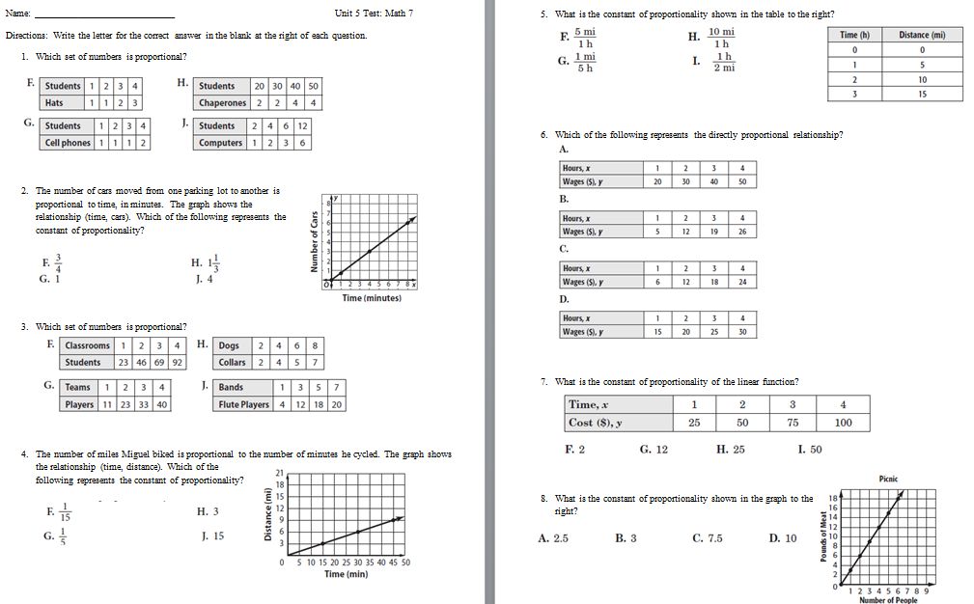
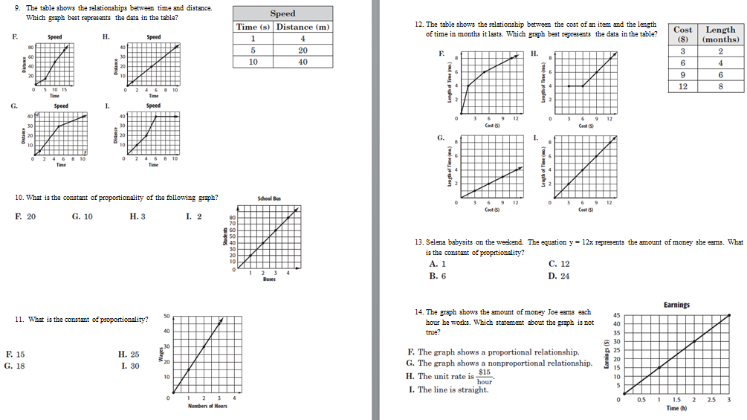

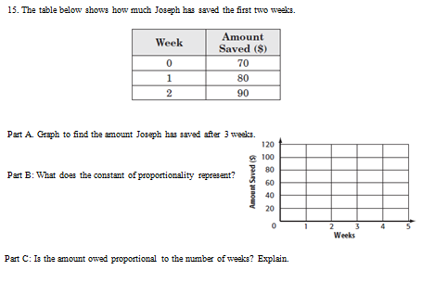

At the completion of the initial lesson, discussed throughout this report, students were asked to provide teacher feedback on their findings concerning the instruction. The survey is shown below and the results were used to modify other lessons throughout the unit and in other units.
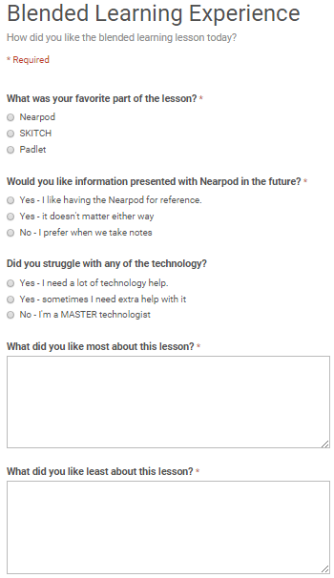
Evaluation Materials
Formative assessment materials included the following:
- Pre-Assessment
- Nearpod
- SKITCH
- Padlet
- SKITCH Checklist
- Padlet Rubric
- Google Classroom
- Paper/Pencil
- Graph paper
- Warm-Ups
- iPads
Summative Assessment Materials
- Paper/pencil assessment
- Multiple choice questions
- Extended response question
- Google Forms
- Google Classroom

Procedures
The assessment was given in the classroom setting. Students had 50 minutes to complete a 15 question assessment. Students came into the classroom and sat in their assigned seats. They were given the assessments, the directions were read, and students started the assessment. The teacher projected a timer so that students could manage their time while taking the assessment. A verbal warning was given by the teacher at 15 minutes and five minutes. A small group requiring the assessment items be read was pulled to the small group work area and the teacher read the assessment questions every three minutes. This left 8 minutes for the extended response question. At the completion of 50 minutes, the teacher told students to double check that they had circled all answers and that their name was on the top of the test. The test was then turned into the turn-it-in basket. Students whose accommodations give them extended time turned in their assessments last and completed their assessments the next day during small group. There were no specific concerns, other than those mentioned at the beginning of this report.

