Report 1 – Pre-instructional Components
Principles of Instructional Design
Michelle Wood

Setting
The instruction will occur in a seventh grade math classroom at Forestbrook Middle School. Forestbrook Middle School is located in Myrtle Beach, South Carolina. The community is a coastal community within the Horry County School District. There are approximately 1200 students at the school, and although not considered at Title One school, approximately 70% of the students receive free and reduced lunch. The school was named Palmetto’s Finest for the 2014-15 school year, and a National Blue Ribbon School in the fall of 2015. The community is highly involved in the school.

The classroom has a one to one digital device to student ratio. The analysis will occur during the second block of the day in a general education math 7 class. The time of day is 9:20-10:20am. There is one teacher in the classroom. The class is required to complete at least one hour and twelve topics of digital learning on ALEKS math, per district guidelines, weekly. The students in this classroom have different reading and mathematical capabilities. Most students in the classroom tested at the In Need of Support or Close levels during the last state testing administration. Current MAP data is in line with the Spring ACT administration. A complete analysis of students is available later in this report.

This course is required for all seventh grade students unless they have been placed in honors or accelerated math program. Some of the students are highly motivated to learn, while others show an extreme distaste for mathematics in general. Reading is an area where several students struggle; this is evidenced when reading is required in mathematics – primarily word problems.

Rationale
The lesson is part of the Ratio and Proportional Relationships in the Coordinate Plane unit. It is part of the sequence of learning mandated by the state and the district for seventh grade students. The unit is the fifth unit of instruction, the second in the Ratio & Proportions strand. The content is directly aligned to the South Carolina College and Career Ready Standards of Mathematics and the Horry County Consensus Map that was created using the SCCCRS – Mathematics. Students are expected to show mastery of this unit in the state testing at the end of the year.
Skitch, Google Classroom, Nearpod, and ALEKS were all chosen for use in this lesson to promote the technology initiatives of the school and district. These are resources that students have been exposed to previously in my classroom and in other classrooms during this academic year. Choosing familiar mediums gives student more opportunity to learn the content and less time learning different apps that contribute the same functions to learning.

Description of Context
Teachers have been given iPads and laptops through technology initiatives at the district level. Teachers are encouraged to implement blended learning and small group instruction several times throughout the week. Each student in the district, middle and high school, have been issued a digital learning device to ensure teachers are implementing the blended learning model in the classroom. Digital content is required by the district in both ELA and Mathematics. There is a time and topic requirement issued by the district for this digital content. There is no exception for students without devices. Another push by the district is to offer differentiated instruction. At our school, we are encouraged to use Khan Academy for remediation with students in one of our blended learning rotations, or small group to give students support in autonomous learning.

Description of Learners
The class has twenty-nine students. Of the students in the classroom there are two that are served by the RBHS (Rehabilitative Behavioral Health Services) program at the school, three being served by the ESOL services at the school and two students that are served by the special education programs (one with an IEP and one with a 504). There are several students (seven) diagnosed with ADHD that do not receive special education services. In the classroom there are twenty males and nine females. All students in the class receive free or reduced lunch, with one exception. The class has twenty-one Caucasian/White students, five African-American/Black students, two students identifying as two or more races, and two students that are identified as Native Hawaiian or Pacific Islander. The complete learner profile is provided on the next page.
Performance Context of Learners

The students come from three different elementary schools and this is a source of differentiated backgrounds. Background knowledge and motivational mindsets of learners vary significantly. Some students in the classroom are motivated to do well intrinsically, some motivated by reward, and others motivated by their need to be in a warm, safe environment. Though all students are considered of low socio-economic status, there are some much lower on the SES scale. There is a 28 point MAP score spread within this group of students. For this particular strand there is a 36 point MAP score spread. This causes the highest students to become disengaged if the material is not available to provide a stretch activity. The lower students need several scaffolding opportunities before learning the new material.

Although we can provide students with free technology, there is still a unique divide when students do not have technological access at home. It is critical that entry competencies are pre-assessed so that remediation can happen before introducing new topics, which could put students further behind. Multiple facets of lesson must be planned to account for students who have lost iPad privilege or who have lost their iPad due to breakage. Because of the range of mathematical understanding, it is critical that students are able move on after mastering the content so they do not become disengaged, digital content has been very useful for this reason.

The table below shows a snapshot of the preceding information. It has been organized to give the reader and complete overview of the group dynamic of the students in the classroom. Totals can be found at the bottom of each column.
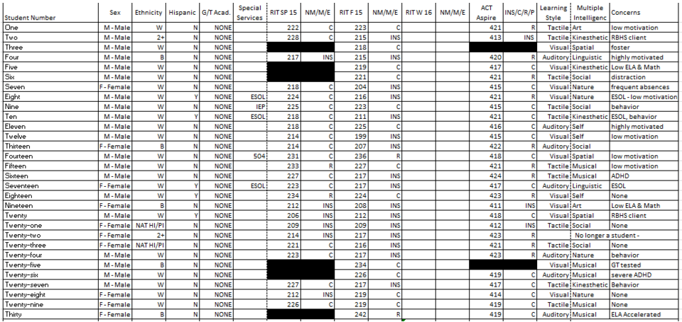

Instructional Goal Statement
The learners will be able to identify and model proportional relationships given multiple representations, including tables, graphs, equations, diagrams, verbal descriptions and real world situations (7.RP.2) using a digital device and the following technologies: Google Classroom, SKITCH, Nearpod, Padlet and ALEKS. They will be able to identify the unit rates as the constant of proportionality and use equations to model proportionality. Students should also be able to label the graph of a proportional relationship with key features using digital applications. Students should be able to work collaboratively to create a study tool by describing a scenario.

Goal Analysis
- Students will be able to use a table to calculate the constant of proportionality using Nearpod.
- Students will be able to use a graph to calculate the constant of proportionality using Nearpod.
- Students will be able to recognize the constant of proportionality when given an equation using Nearpod.
- Students will be able to label specific points (origin and unit rate) on a graph using SKITCH.
- Students will be able to tell the real world situation of a graph or table using Padlet.

Subskills Analysis
- Students will need to know how to operate Nearpod.
- Students will need to know how to submit using Padlet.
- Students will need to know how to submit using Google Classroom.
- Students will need to know how to label using SKITCH.
- Students will need to know how to calculate constant of proportionality.
- Students will need to know how to read a graph.
- Students will need to know how to recognize a proportional relationship from a graph.
- Students will need to know how to find a proportional relationship from a table.
- Students will need to know how to identify a proportional equation.

Entry Behavior Analysis
- Students can use Nearpod, Padlet, Google Classroom, and SKITCH.
- Students know how to divide.
- Students know the x and y axis on a graph.
- Students know the independent and dependent variables in a table.
- Students know how to make ordered pairs from a table.
- Students know how to use ordered pairs to make a graph.
- Students know how to tell a verbal story.

